**Sharmain Matlock-Turner**

**Urban Affairs Coalition**

President and CEO

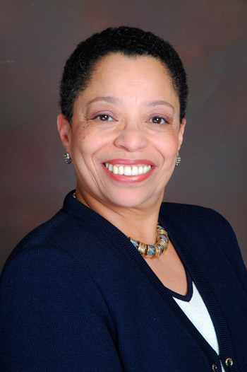**Sharmain Matlock-Turner** is the President and CEO of the Urban Affairs Coalition. She began her tenure at the Coalition in March of 1999, with a special distinction as the first woman to lead in the organization’s 46-year history. The Urban Affairs Coalition, formerly GPUAC, unites government, business, neighborhoods, and individual initiative to improve the quality of life in the region. In partnership with a diverse Board of Directors, made up of business, nonprofit and community leaders, Ms. Matlock-Turner and her team of managers and more than 350 employees forge partnerships and build consensus to help families reduce poverty and reach the middle class. The organization’s efforts are focused in four areas: improving life changes for youth and young adults; building wealth in low income communities; strengthening the grassroots nonprofit sector; and forging strategic partnerships across sectors and communities.

Ms. Matlock-Turner is founder and chair of the seventeen-year-old, West Oak Lane Charter School. In addition, she serves on the following boards and commissions: Philadelphia Facility Management Corporation, which owns Philadelphia Gas Works (PGW); Peirce College Board of Trustees; Entrepreneur Works, Board of Directors; Greater Philadelphia Chamber of Commerce; Children’s Scholarship Fund Philadelphia; Philadelphia Civil Service Commission Nominating Panel; Philadelphia Council for College and Career Success; African American Chamber Foundation Board of Directors and the Citizens Bank Advisory Committee.

In 2010, Ms. Matlock-Turner was appointed by Mayor Michael Nutter to serve as Chair of the Advisory Committee for the Office of Economic Opportunity, an initiative to improve contracting and employment opportunities for women, the disabled and people of color in Philadelphia. She also serves a Chair of the FMC tower at Cira Centre South Economic Opportunity Oversight Committee, member of the 2016 DNC Diversity Committee and Comcast EOP Oversight Committee.

Ms. Matlock-Turner has received numerous awards recognizing her hard work and commitment to families and communities. Over the past few years, she has been the recipient of the Valley Youth House Community Achiever of the Year Award, Take the Lead Award from Girl Scouts of Eastern Pennsylvania and she has received the Citizen Volunteer of the Year Award from the United Way of Southern Pennsylvania. She was the first woman to receive the LaSalle University Leadership Award, the Imprint Award from the People’s Emergency Center, the Civic Investment Award from Community College of Philadelphia, the American Red Cross Clara Barton Award, the Honorary Myrna Field Award from CASA Philadelphia, and Women in the NAACP Award.

She has also been honored by the Women’s Christian Alliance, the American Women’s Heritage Society, Pennsylvania Senate, Pennsylvania House of Representatives, City of Philadelphia, OARC, Black United Fund, WOMENS WAY, Philadelphia Business Journal, Philadelphia Tribune, the March of Dimes, CLARIFI and the Federal Reserve Bank. She received the first Helena T. Devereux Leadership Award, presented by The Devereux Foundation.

Ms. Matlock-Turner is often asked to speak to local, regional and national organizations. She is a regular guest on 6abc's public affairs television program *Inside Story*.

Ms. Matlock-Turner holds a BS degree in Education from Temple University. In 2005, she was one of three Philadelphia nonprofit leaders selected to receive a scholarship to the Harvard Business School’s nonprofit leaders' summer program. In 2014 she received an Honorary Doctorate Degree of Humane Letters from Peirce College. She is a Philadelphia resident and is married to Tony Turner with two grown daughters, Ayanna Matlock and Naima Turner and is the grandmother of Joshua Matlock Hale.

Prior to being named President and CEO of the Urban Affairs Coalition, Ms. Matlock-Turner was associate vice president, legislative and community affairs for Mercy Health System and AmeriHealth Caritas. Before that, Ms. Matlock-Turner was chief of staff to the late Pennsylvania State Senator Roxanne H. Jones.